
SESSION 2023-2027

BACHELOR OF SCIENCE IN
SOFTWARE ENGINEERING SUBMITTED BY

Muhammad Sarab Rafique 23-NTU-CS-1191 Muhammad Taaha 23-NTU-CS-1193
Sheharyar Akhtar 23-NTU-CS-1210

SUPERVISED BY

Dr. Zahid Javed

CO-SUPERVISED BY

Mr. Abdul Basit
Department of Computer Science National Textile University, Faisalabad

CERTIFICATION

This Document, which has been written by Muhammad Sarab, Muhammad Taaha, Sheharyar Akhtar under the directions of our supervisor and co-supervisor and approved by all members of the thesis committee, has been presented to and accepted by the Chairman of the Department of Computer Science, in fulfillment of the requirement of the degree of Bachelor of Science in Software Engineering.

DECLARATION

We hereby declare that this document is completely written by us, and it is totally our effort and none of anyone from outside of our group has copied it. This Report is purely written in a technical way in accordance with our project.

Group Members:

Sarab Cheema
23-NTU-CS-1191
E-Mail: sarabcheema160@gmail.com
Signature |  | Date

Muhammad Taaha
23-NTU-CS-1193
E-Mail: muhammadtaaha365@gmail.com
Signature |  |  | Date

Sheharyar Akhtar
23-NTU-CS-1210
E-Mail: sheharyarakhtar1210@gmail.com
Signature |  |  | Date

Acknowledgement

First, In the Name of Allah, the Most Beneficent, the Most Merciful. All the praises and thanks be to Allah. A lot of love for our beloved Holy Prophet MUHAMMAD (S.A.W); his guidance always helps us to get the right path.
After that, we also proudly declare that the success parameters of this project are the endless prayers and support of our parents.
We wish to express our sincere gratitude and acknowledge the efforts of our supervisor, who helped us a lot with the project, especially with the documentation. Every time we wanted to meet him, he was always there for us with great ideas, discussions, and suggestions that helped us complete our project and documentation.
Special thanks are extended to Dr. Zahid Javed and Sir Abdul Basit, our Supervisor and Co-Supervisor, who provided invaluable guidance and support throughout the Software Requirement Specification (SRS) and development process. The authors would also like to specifically acknowledge the invaluable support and technical suggestions provided by Dr. Zahid Javed.
This document and the resulting project, Task Flow, would not have been possible without the support and cooperation of all involved individuals. The authors are confident that this document will serve as a comprehensive guide for the further development and implementation of the Task Flow management system.

ABSTRACT

Fledge is a smart quiz builder application developed using Next.js that enables teachers to create timed MCQ quizzes with correct answers and generate QR codes for student access. Students can scan the QR code, enter their name, attempt the quiz on the same page, and view their results after the quiz ends. All quiz and result data are stored in a database, allowing teachers to view student results by quiz name. The system also includes a machine learning model trained on a predefined dataset to predict whether a student will pass or fail, making Fledge an efficient and intelligent digital assessment platform.

TABLE OF CONTENTS

Content Description Page No

Contents
CERTIFICATION 2
DECLARATION 3
Acknowledgement 4
ABSTRACT 5
TABLE OF CONTENTS 6
Table Of Figure 9
Table of Table 10
CHAPTER 1 1
1. PROJECT INITIATION 2
1.1 Introduction 2
1.2 Background of the Study 2
1.3 Project Scope 2
1.3.1 Authentication and Role Management: 2
1. Authentication and Role Management 2
2. Quiz Creation 2
3. Quiz Attempt 2
4. Result Management 3
5. Machine Learning Prediction 3
6. Database Integration 3
7. Technology Stack 3
1.4 Stakeholders 3
1.5 Current/existing systems 3
1.6 The limitation of current systems 4
1.7 Problem Statement 4
1.8 Objectives 5
1.9 Project Goals 5
1. Easy Quiz Creation 5
2. Seamless Student Access 5
3. Instant Result Generation 5
4. Efficient Data Management 5
5. Performance Prediction 5
6. Responsive and User-Friendly Platform 5
1.10 Risks 5
1.11 Project Scheduling 6
CHAPTER 2 8
2. LITERATURE REVIEW 9
2.1 Introduction 9
2.2 Overview of Real-Time Communication and File Sharing Systems. 9
2.3 Related Work in File Sharing and Collaboration Platforms 9
2.4 Motivation for Developing Fledge 10
2.5 Summary: 10
CHAPTER THREE 11
3. METHODOLOGY AND REQUIREMENTS 12
3.1 Introduction 12
3.2 Existing Methodologies: 12
3.3 General requirements 14
CHAPTER FOUR 15
4. SYSTEM ANALYSIS AND DESIGN 16
4.1 Introduction 16
4.2 Use Case Diagram 16
4.3 Activity Diagram 23
4.4 Class Diagram 27
4.5 Sequence Diagram 29
4.6 Database Design 30
CHAPTER 5 33
5. IMPLEMENTATION 34
5.1 Introduction 34
5.2 Front End User Panel: 34
CHAPTER 6 39
6. TESTING 40
6.1 Introduction 40
6.2 Types of Testing 40
6.3 Documentation 41
CHAPTER 7 43
7. CONCLUSION AND RECOMMENDATION 44
7.1 Strengths 44
7.2 Weaknesses 44
7.3 Future Enhancement 45
7.4 Scope of the project 45
7.5 Software performance 46
7.6 Recommendation 46
REFERENCE 46

Table Of Figure

Page No
Figure 1 Agile Model 14
Figure 2 Sign In/Sign Up Use Case 22
Figure 3 Tailor Use Case 23
Figure 4 Use Case Diagram 24
Figure 5 User Activity Diagram 31
Figure 6 Activity Diagram 32
Figure 7 Class Diagram 34
Figure 8 Sequence Diagram 36
Figure 9 Entity relationship diagram ERD. 38
Figure 10 Sign In page 40
Figure 11 SignUp Page 41
Figure 12 Reset Password 41
Figure 13 Admin Dashboard 42
Figure 14 Profit and loss Graph 42
Figure 15 Add Customer 43
Figure 16 Add Staff 44
Figure 17 View Staff 44
Figure 18 Salary 45
Figure 19 Add Designation 45
Figure 20 Add Expense Category 46
Figure 21 Add Expense 46

Table of Table

Page No
Table 1 Stakeholders involved in the project development. 4
Table 2 Manage Order use case 25
Table 3 Manage Customer use case 26
Table 4 Manage Staff Use Case 26
Table 5 Track Financials Use Case 27
Table 6 Customize Garments Use Case 28
Table 7 Generate Report Use Case 28
Table 8 Traceability Matrix 51

CHAPTER 1

PROJECT INITIATION

Introduction
Fledge is a smart online quiz application designed to make digital assessments easy and efficient. Teachers can create timed MCQ quizzes, add correct answers, and generate QR codes for students to access. Students can scan the QR code, enter their name, attempt the quiz online, and see their results instantly.
All quiz data and results are stored in a database for easy management. The platform also uses a machine learning model trained on a default dataset to predict whether a student will pass or fail. Built with Next.js, Fledge provides a fast, simple, and intelligent solution for modern digital learning and assessment.

1.2 Background of the Study

With the rapid growth of digital learning, traditional paper-based quizzes have become less efficient, time-consuming, and prone to errors. There is a growing need for automated, accessible, and interactive assessment systems that provide instant feedback and track student performance effectively. Fledge addresses this need by offering a QR-based online quiz platform where teachers can create timed MCQ quizzes, and students can attempt them easily on mobile devices. By integrating a database for storing results and a machine learning model to predict pass or fail outcomes, fledge enhances the learning process and helps teachers monitor student performance efficiently.

1.3 Project Scope
The scope of this project involves the end-to-end development and deployment of a web-based application specifically designed for users requiring secure file sharing. The application incorporates the following core modules:

Authentication and Role Management:

1. Authentication and Role Management
- Secure login system for teachers and students.
- Role-based access to differentiate teacher and student functionalities.

2. Quiz Creation
- Teachers can create timed MCQ quizzes.
- Add questions with correct answers.
- Generate QR codes for quizzes.

3. Quiz Attempt
- Students can scan QR codes to access quizzes.
- Enter name and attempt quiz on the same page.
- Auto-submit when time expires.

4. Result Management
- Automatic calculation of marks and percentage.
- Display instant results to students.
- Teachers can view results by quiz name.

5. Machine Learning Prediction
- Predict student outcomes as pass or fail.
- Trained on predefined dataset for accuracy.

6. Database Integration
- Store quizzes, student responses, and results securely.
- Enable easy retrieval and analysis of data.

7. Technology Stack
- Frontend: Next.js, Tailwind CSS.
- Backend: Next.js API routes with database (Supabase).

1.4 Stakeholders

The primary stakeholders of Fledge include teachers, who design and manage quizzes, evaluate student progress, and analyze performance through detailed reports; and students, who attempt quizzes, receive instant feedback, and use results to improve their learning outcomes. Educational institutions are also key stakeholders, as they benefit from centralized assessment management, performance tracking, and data-driven academic insights.
In addition, recruitment organizations, corporate training departments, and interview panels are important stakeholders. These organizations use Fledge to conduct online assessments, evaluate candidate credibility, verify skills, and shortlist applicants efficiently during hiring or internship processes. The platform helps them ensure fair evaluation through standardized testing and analytics-based decision-making.
Furthermore, system administrators and developers act as internal stakeholders responsible for system maintenance, database management, machine learning model optimization, and ensuring data security, scalability, and overall system reliability. Together, these stakeholders contribute to making Fledge a reliable, secure, and effective assessment and evaluation platform for both academic and professional use.

1.5 Current/existing systems

In the current system, most quizzes and assessments are conducted manually using paper-based methods or basic online forms. Teachers prepare quizzes and distribute them physically or via simple online tools, while students submit their answers without instant feedback. Result calculation is often manual or delayed, and there is little to no prediction or analysis of student performance. The system lacks automation, QR-based access, real-time scoring, and intelligent insights, making it time-consuming and less efficient for both teachers and students.
Stakeholder | Interest | Importance
Teachers | Quizzes | High
Students | Learning | High
Institutions | Efficiency | Medium
Developers | Maintenance | Medium

Table 1 Stakeholders involved in the project development.

1.6 The limitation of current systems
• Manual quiz creation and distribution.
• Delayed or no instant result feedback.
• No automated performance analysis or prediction.
• Time-consuming for teachers and students.
• Limited accessibility and lack of mobile-friendly options.

Problem Statement

Traditional quiz and assessment systems are often manual, time-consuming, and lack instant feedback. Students do not receive immediate results, and teachers face difficulties in managing quizzes and analyzing performance efficiently. Many online organizations currently conduct assessments using basic tools such as Google Forms or similar platforms, which often lack strict time limitations, advanced automation, and effective monitoring mechanisms. As a result, these assessments may not accurately evaluate a candidate’s true skills. Existing online solutions also offer limited mobile accessibility and lack intelligent prediction of student outcomes. Fledge addresses these challenges by providing a QR-based, automated quiz platform with configurable time limits, real-time scoring, secure database support, and an integrated machine learning model to predict pass or fail outcomes, ensuring a more reliable, efficient, and fair assessment process.

1.8 Objectives

- To develop a QR-based online quiz platform for easy access by students.
- To enable teachers to create timed MCQ quizzes with correct answers.
- To provide instant result calculation and display for students.
- To store all quiz data and results securely in a database.
- To implement a machine learning model to predict pass or fail outcomes.
- To make the platform responsive, user-friendly, and efficient using Next.js.

Project Goals

1. Easy Quiz Creation
The system aims to allow teachers to create quizzes quickly and efficiently. Teachers can add multiple-choice questions, set correct answers, and define quiz duration with minimal effort.

2. Seamless Student Access
Students should be able to access quizzes easily using QR codes. By scanning the QR code and entering their name, they can attempt the quiz on the same page without any technical difficulty.

3. Instant Result Generation
Fledge ensures that student responses are evaluated automatically. Students receive instant scores and percentages once the quiz ends, making the assessment process faster and more transparent.

4. Efficient Data Management
All quiz questions, student responses, and results are stored securely in a database. This ensures easy retrieval, organization, and tracking of performance over time.

5. Performance Prediction
The system includes a machine learning model trained on a predefined dataset. It predicts whether a student will pass or fail, providing valuable insights into student performance and learning outcomes.

6. Responsive and User-Friendly Platform
Built using Next.js and modern frontend tools, fledge aims to provide a responsive and intuitive interface for both teachers and students, making digital assessments smooth and efficient.

Risks
• System Errors – Quizzes may fail to load or submit due to technical glitches.
• Data Loss – Student responses or results may be lost if the database fails.
• Incorrect Predictions – The machine learning model may give wrong pass/fail results.
• User Misuse – Students may share QR codes or attempt quizzes dishonestly.

Project Scheduling

The most fundamental part of project management is scheduling. The project calls for breaking it up into activities and working on a set timeline. There needs to be a schedule for each action. The successful completion of the Project is the goal of project scheduling. Our project planning is depicted as follows:

Tasks: | Sep | Oct | Nov | Dec | Jan
Topic Selection
Finalize Topic
Gather
Requirements
Analyze
Requirements
SRS Document
Write
Document/Code
Testing &
Modification
Submit
Table 1.1 Project Timeline

CHAPTER 2

LITERATURE REVIEW

Introduction

With the rise of digital learning, traditional paper-based quizzes are becoming inefficient and time-consuming. Many existing online assessment tools lack automation, instant feedback, and performance prediction. Research shows that QR-based access and machine learning can improve digital assessments by making them faster, more accessible, and smarter.
Fledge addresses these challenges by providing a QR-enabled quiz platform where teachers can create timed MCQs, students can attempt quizzes on mobile devices, and results are stored securely in a database. The system also uses a machine learning model to predict pass or fail outcomes, helping improve learning efficiency and performance monitoring.

Overview of Real-Time Communication and File Sharing Systems.

Fledge incorporates the core concepts of real-time communication and data sharing to support efficient digital assessments. In the context of Fledge, real-time communication refers to the instant interaction between users and the system during quiz creation, quiz attempts, and result generation. Teachers create quizzes and immediately make them available to students through QR codes, while students receive instant feedback once the quiz is completed.
File and data sharing in Fledge is achieved through secure database operations, where quizzes, MCQs, student responses, and results are stored and retrieved in real time. This enables seamless access to quiz information and results without delays. By combining real-time interaction, automated data sharing, and intelligent processing, fledge ensures fast, reliable, and efficient communication between teachers, students, and the system, enhancing the overall digital assessment experience.

Related Work in File Sharing and Collaboration Platforms

File sharing and collaboration platforms have become essential tools in modern digital learning environments. Many existing systems allow educators to share learning materials, conduct online quizzes, and collect student responses using web-based platforms. These systems commonly provide features such as file uploads, online submissions, and basic result viewing, which support collaboration between teachers and students.
However, most existing platforms are limited in terms of automation and intelligent assessment. They often require manual sharing of quiz links, lack QR-based access, and provide delayed or basic result analysis. In addition, predictive performance analysis using machine learning is generally not included. Fledge addresses these limitations by enabling real-time sharing of quizzes through QR codes, storing quiz data and student responses in a database, and automatically displaying results. By integrating machine learning–based pass or fail prediction, fledge extends traditional file sharing and collaboration concepts into a smart, efficient, and intelligent digital assessment platform.

Motivation for Developing Fledge

Traditional quizzes and assessments are often manual, time-consuming, and lack instant feedback, making it difficult for teachers to track student performance efficiently. Existing online platforms provide digital quizzes but usually do not offer automated result analysis or predictive insights. There is a need for a system that is accessible, automated, and intelligent, enabling students to take quizzes easily and teachers to evaluate performance quickly.
Fledge was developed to address these gaps by providing a QR-based quiz platform with automatic scoring, secure database storage, and a machine learning model to predict pass or fail outcomes. This motivates the creation of a smart, efficient, and user-friendly digital assessment tool that improves both learning and teaching experiences.

Summary:

In Conclusion Fledge is a QR-based online quiz platform that allows teachers to create timed MCQ quizzes with correct answers, and students to attempt them easily on mobile devices. The system automatically calculates results, stores all data in a database, and predicts pass or fail outcomes using a machine learning model. It provides a fast, efficient, and intelligent solution for digital assessments, improving both teaching and learning experiences.

CHAPTER THREE

METHODOLOGY AND REQUIREMENTS

Introduction
Fledge is a QR-based online quiz platform developed to meet the requirements of automated digital assessments. Using a structured methodology, the system allows teachers to create timed MCQ quizzes, add correct answers, and generate QR codes for easy student access. Students can attempt quizzes on the same page, submit responses automatically when time ends, and view instant results. All data is securely stored in a database, and a machine learning model predicts pass or fail outcomes, ensuring efficient assessment and performance monitoring.

Existing Methodologies:

Several software development methodologies are commonly used in modern system development, including:
• Traditional paper-based quizzes: manual preparation, distribution, and evaluation.
• Time-consuming and prone to human error.
• Basic web-based quiz platforms: timed MCQs with automatic scoring.
• QR code-based access for easier student participation (in some systems).
• Most systems lack machine learning prediction for student performance.
• Limited database integration for storing quizzes, responses, and results.
• Few platforms provide real-time evaluation and mobile-friendly interfaces.

Selected Model

There are other development approaches accessible, however Waterfall methodology is the one that works best for our project.
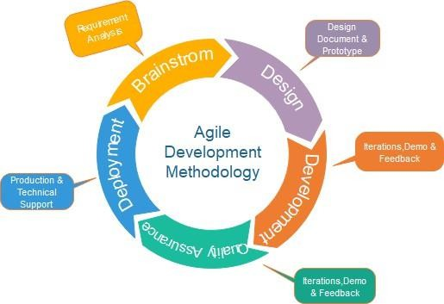

Figure 1 Agile Model

Here is a brief explanation of the process that was chosen. We chose Agile methodology because Agile is a method for developing software that involves self-organizing, cross- functional teams, the customer or end user, and requirements and answers to those requirements. Scrum, Future Driven Development, Extreme Programming, and Crystal are just a few of the different variations of the agile development methodology. The business environment is constantly changing. Because businesses work on a global scale, change happens quickly. These changes can be brought on by new market opportunities, changes in the economy, etc. The ability to embrace change is what gives this Agile its true meaning.

General requirements

User requirements

The system is designed to be intuitive, fast, and secure. Key user expectations include:
- Teachers can create timed quizzes and add MCQs with correct answers.
- Students can scan QR codes, enter their details, and attempt quizzes.
- Teachers can view results by quiz name.
- Students can see instant results after quiz completion.

Functional requirements

The functional requirements describe the core features and behavior of the system. Fledge shall include:
- Quiz creation and management system for teachers.
- QR code generation for student quiz access.
- Automatic result calculation and display.
- Database storage of quizzes, responses, and results.
- Machine learning model for predicting pass/fail outcomes.

Non-Functional Requirements (NFR)
- User-Friendly Interface
The system is easy to use so students and teachers can operate it without training.
- Mobile-Friendly Design
The system works smoothly on mobiles, tablets, and computers.
- Fast Performance
Pages load quickly to avoid delays during quizzes.
- Data Security
Student and quiz data is kept safe and protected from unauthorized access.
- Time-Limited Quizzes
Each quiz has a fixed time limit to ensure fair assessment.
- Instant Results
Students receive results immediately after submitting the quiz.
- Reliable System
The system works correctly without crashing during quiz attempts.
- Error Handling
Errors are handled properly so quiz data is not lost.
- Database Support
All quiz and user data are stored securely in a database.
- Modern Technology
The system is built using Next.js with backend support for better performance and scalability.

CHAPTER FOUR

SYSTEM ANALYSIS AND DESIGN

Introduction
System analysis and design are involved in specifying how the software will work.

The development's system analysis and design phase are to refine the project goals into defined functions and operation of the intended application. System requirements are documented by using the Unified Modeling Language (UML).

These techniques use a diagramming method such as a use case diagram, sequence diagram, activity diagram, and class diagram. Use case diagram explains the system, environment, and the association between the system and its environment. A use case diagram is presented.
Through actors, the actors model the processes involved in the system and give a view of overall system functions.

The sequence diagram explains the scenario of the use cases—the actor's actions and sequences of the issues. Meanwhile, the collaboration diagram presents the interactions which occur among objects in the system. The class diagram is a view of classes and objects involved in the system.

Use Case Diagram

Use case diagrams consist of named pieces of functionality (use cases), the persons or things invoking the functionality (actors), and possibly the elements responsible for implementing the use cases (subjects).
Use case, which describes how people interact with the system. Use case give you a structured way of capturing the behavioral requirements of a system, you can reasonably create a design from them.

Actor


Use Cases

System boundary boxes

Associations

Actor: An actor is a person, organization, or external system that plays a role in one or more interactions with your system. An Actor Include all user roles that interact with the system.

Use Cases: A use case describes a sequence of actions that provide something of measurable value to an actor, a Use case is a collection of related success and failure scenarios, describing actors using the system to support a goal and is drawn as a horizontal ellipse.

System boundary boxes: You can draw a rectangle around the use cases, called the system boundary box, to indicate the scope of your system. Anything within the box represents functionality that is in scope and anything outside the box does not.
Associations: Associations between actors and use cases are indicated in use case diagrams by solid lines. An association exists whenever an actor is involved with an interaction described by a use case. Associations are modeled as lines connecting use cases and actors to one another, with an optional arrowhead on one end of the line. The arrowhead is often used to indicate the direction of the initial invocation of the relationship or to indicate the primary actor within the use case.

Use Case Diagram Log in And Sign Up

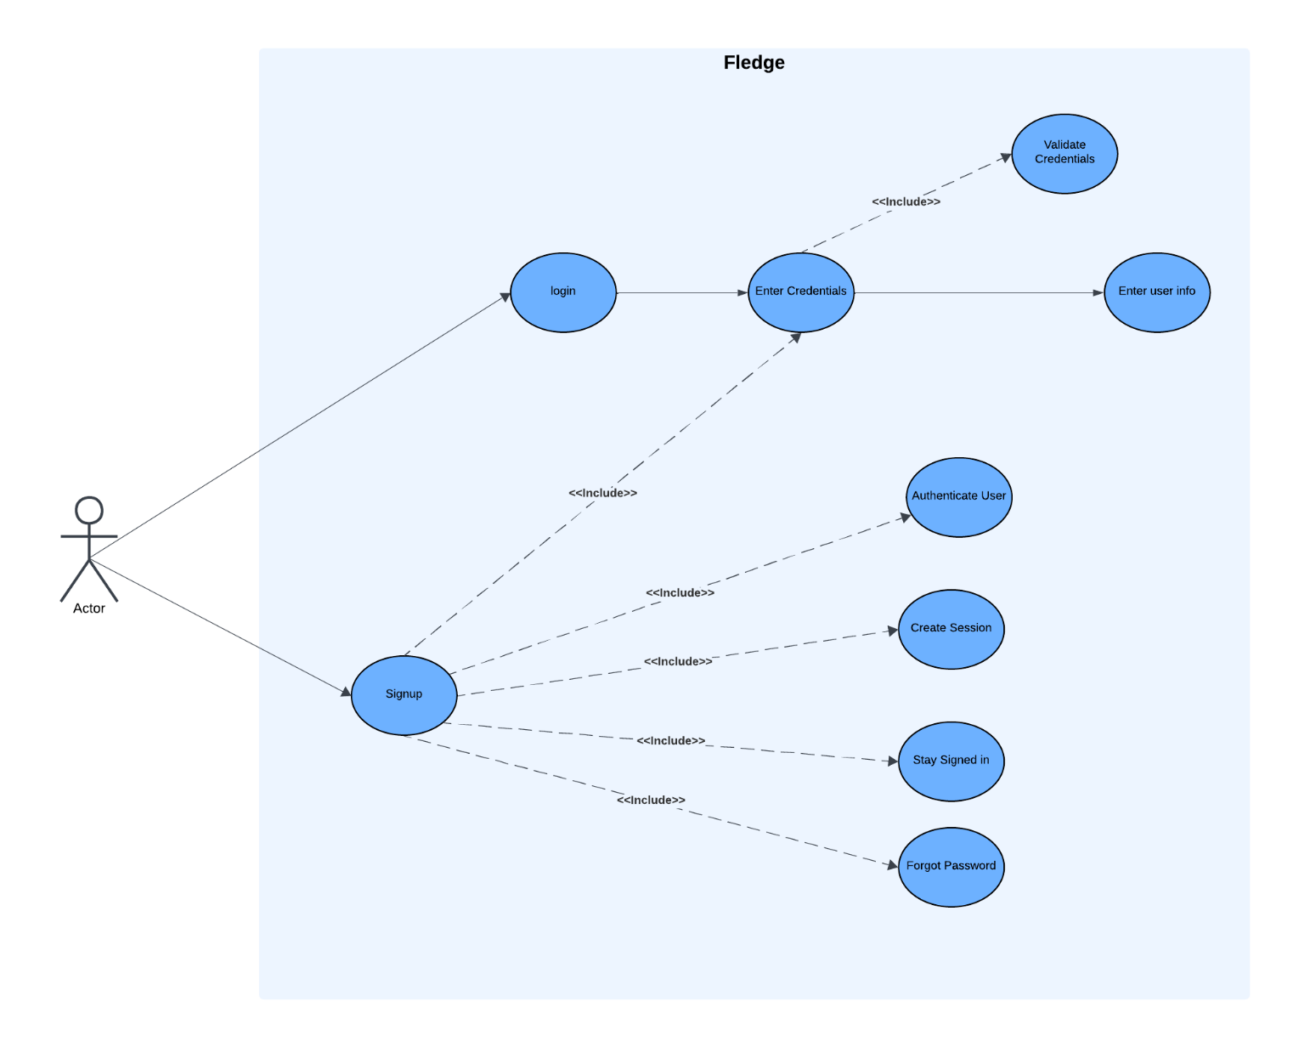

Figure 2 login /Sign Up Use Case

Quiz Builder Use Case Diagram

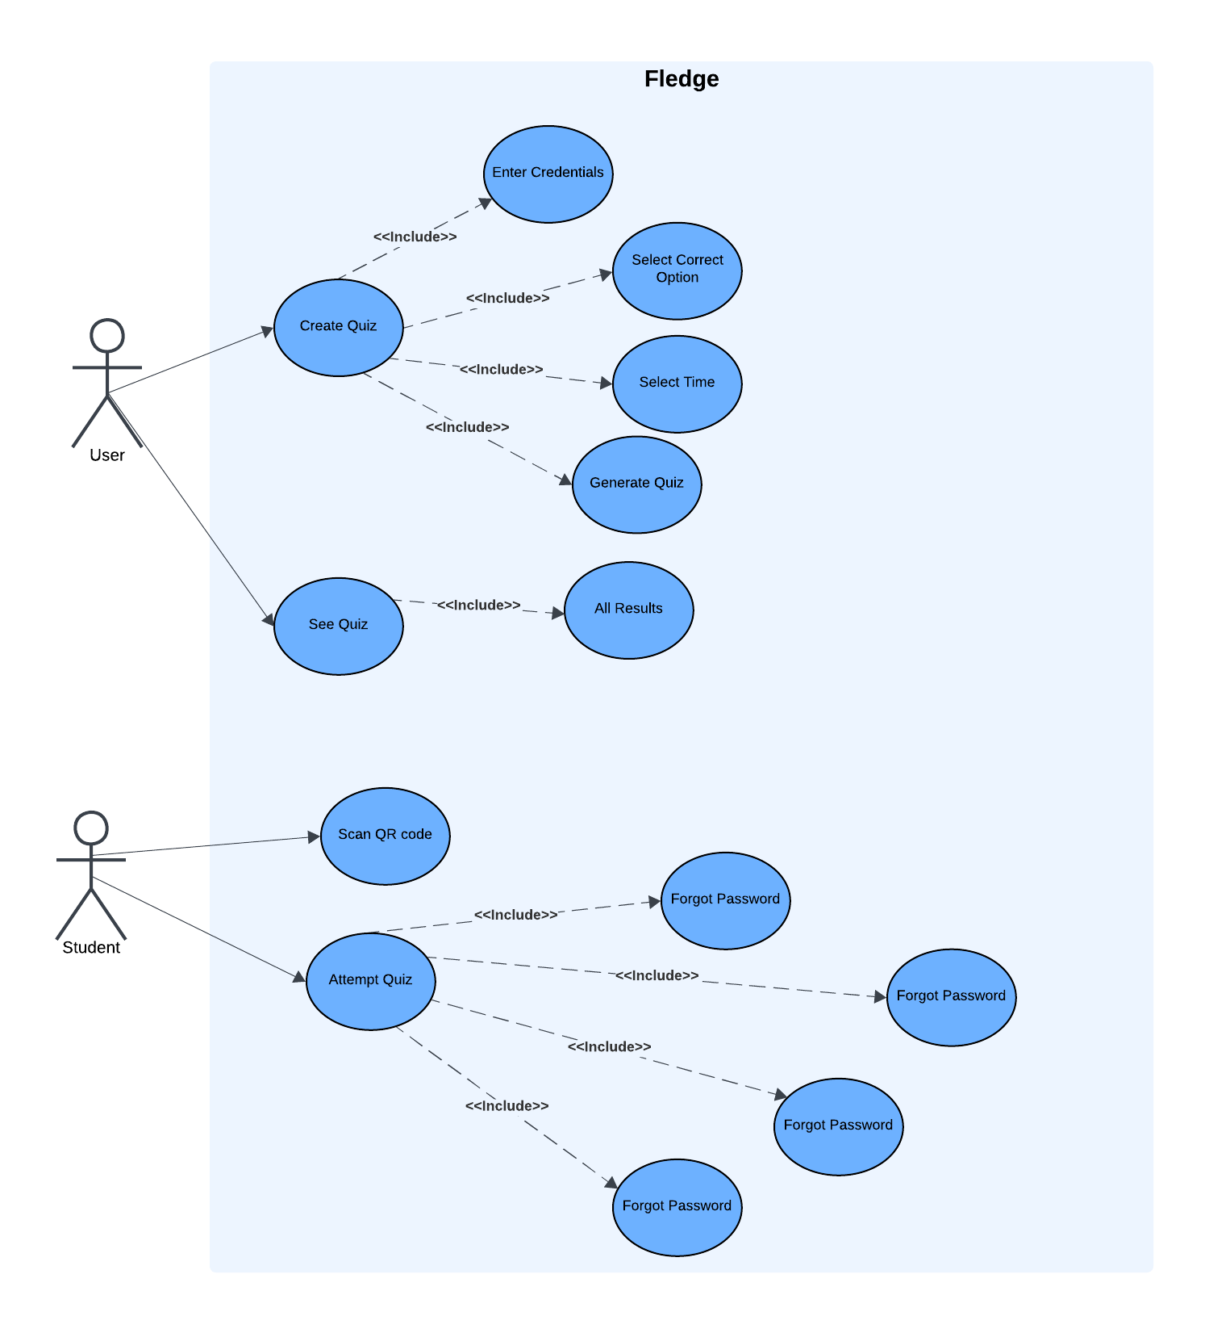
Figure 3 Quiz Builder Use Case

Performance Prediction Diagram:
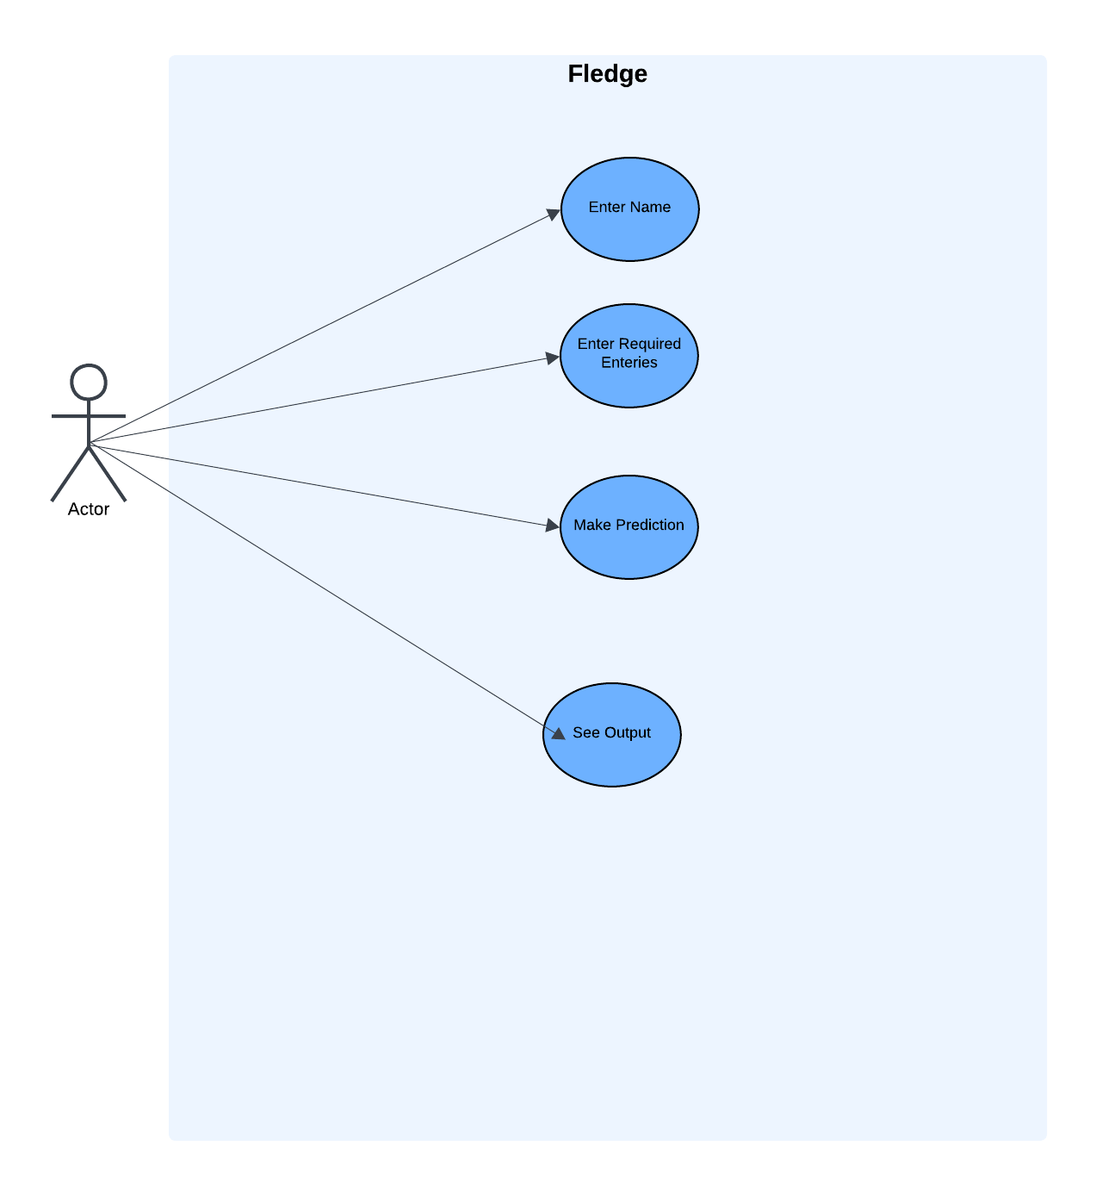

Figure 4 Use Case Diagram

Use cases description:
Use case description contains each information (use case id, use case name, description, pre and post conditions) of each use case.

Table 1 User Authentication use case.

Use Case ID | UC1
Use Case Name | User Authentication
Priority | High
Actor | Teacher / Student
Pre-Condition | User has a registered account and is on the Login page.
Basic Path | 1.User enters email and password.  2. System validates credentials via backend API and database.  3. User is redirected to the dashboard (Teacher: Quiz creation/results, Student: Quiz attempt page).
Description | Allows teachers and students to securely log in to access system features such as quiz creation, quiz attempts, results, and performance prediction.
Post-Condition | User is successfully authenticated and authorized to use the respective features of Fledge.

Table 2 Quiz Creation Use Case.

Use Case ID | UC2
Use Case Name | Quiz Creation
Priority | High
Actor | Teacher
Pre-Condition | Teacher is logged in and on the quiz page.
Basic Path | 1. Teacher selects “Create Quiz”.  2. Teacher adds MCQs with options and selects correct answers.  3. Teacher sets quiz time.  4. System saves the quiz to the database.
Description | Allows teachers to create timed MCQ quizzes and store them in the database for student access.
Post-Condition | Quiz is successfully created and available for students to attempt via QR code.

Table 3 QR Code Page Use Case

Use Case ID | UC3
Use Case Name | QR Code Generation
Priority | High
Actor | Teacher
Pre-Condition | Teacher has created a quiz.
Basic Path
  1. Teacher selects “Generate QR Code” for the quiz.
  2. System generates QR code linked to the quiz URL.
  3. Teacher shares the QR code with students.
Description | Generates a unique QR code for each quiz to provide easy access for students.
Post-Condition | Students can scan the QR code to access the quiz.

Table 4 Quiz Attempt Use Case

Use Case ID | UC4
Use Case Name | Quiz Attempt
Priority | High
Actor | Student
Pre-Condition | Student is logged in or enters name and QR code to access quiz.
Basic Path | 1. Student scans the QR code.  2. Student enters name and roll number.  3. Student attempts the quiz within the given time.  4. System auto-submits the quiz when time ends.
Description | Allows students to attempt quizzes in real time and ensures automatic submission when the timer expires.
Post-Condition | Student quiz responses are saved in the database for result calculation.

Table 5 Result Viewing Use Case

Use Case ID | UC5
Use Case Name | Result Viewing
Priority | High
Actor | Teacher / Student
Pre-Condition | Quiz has been completed by students and data is stored in the database.
Basic Path | 1. Student views their individual result after quiz submission.  2. Teacher selects a quiz by name to view all student results.  3. System calculates marks, percentage, and displays results.
Description | Enables instant result display for students and allows teachers to monitor student performance by quiz name.
Post-Condition | Results are displayed and saved for future reference and analysis.

Table 6 M/L Prediction Use Case

Use Case ID | UC6
Use Case Name | ML Pass/Fail Prediction
Priority | Medium
Actor | System (Backend)
Pre-Condition | Student quiz responses are submitted and stored in the database.
Basic Path
  1. System retrieves student quiz data.
  2. ML model analyzes responses based on predefined dataset.
  3. System predicts whether the student will pass or fail.
  4. Prediction result is displayed to the teacher or student.
Description | Predicts student performance using machine learning to provide insights into pass/fail outcomes.
Post-Condition | Pass/fail prediction is stored and can be used for performance monitoring.

Activity Diagram

Activity diagrams are used during the design phase of complex methods. Alternatively, the Activity diagram can also be used during analysis to break down the complex flow of a use case.
An activity diagram represents an executed set of procedural system activities and is considered a state chart diagram variation. Activity diagrams describe parallel and conditional actions, use cases, and system functions at a detailed level.

In our system, there are a lot of activity diagrams, so we take the most important activities we use frequently. And they are as follows:

b
Action

Edge (control flow)

Decision node



Initial node


Final node

Action: An action is an individual step within an activity, such as a calculation step that is not deconstructed further. That does not necessarily mean that the action cannot be subdivided into the real world, but this diagram will not be refined further.

Edge (Control Flow): Edges, represented by arrows, connect the individual components of activity diagrams, and illustrate the control flow of the activity.

Decision node: The diamond represents a conditional branch point or a decision node. A decision node has one input and two or more outputs.

Initial node: The initial node is the starting point of an activity. An activity can have more than one initial node; in this case, several flows start at the beginning of a movement.

Final note: The activity last node indicates that an action is completed. An activity diagram can have more than one exit in the form of final activity nodes.

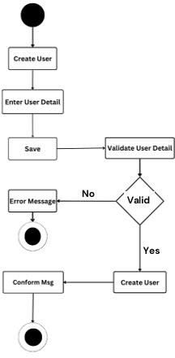

Figure 5 User Activity Diagram

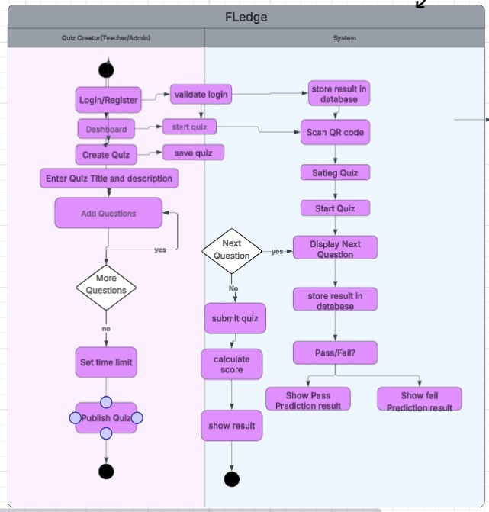

Figure 6 Activity Diagram

Class Diagram

The class diagram is the primary building block of object-oriented modeling. It is used both for general conceptual modeling of the systematics of the application.
A class diagram describes the types of objects in the system and the various static relationships among them. Class diagrams also show the properties and operations of a class and the constraints that apply to how objects are connected. The UML uses the term feature as a general term that covers the properties and processes of a class. A class represents the operations and attributes of one or more objects within your system.

Class

Relationship

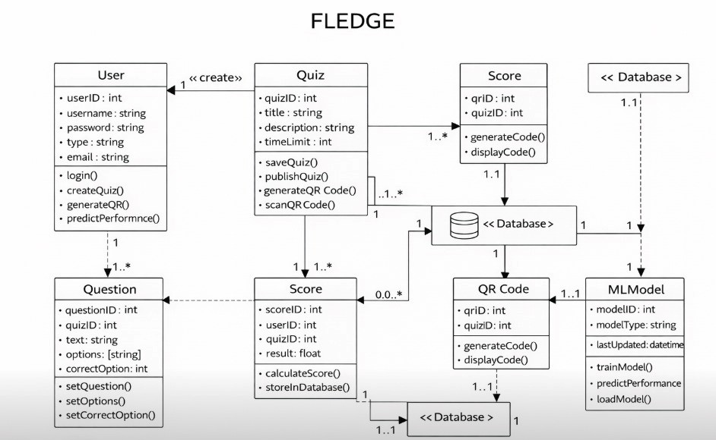

Figure 7 Class Diagram

Sequence Diagram
The primary purpose of a sequences diagram is to define event sequences that result in some desired outcome. The chart conveys this information along the horizontal and vertical dimensions: the vertical dimension shows, top-down, the time sequence of messages/calls as they occur, and the flat dimension shows, left to right, the object instances that the messages are sent to. So that the sequence diagram of our project is as follows:
Once you have completed the sequence diagram, look at the corresponding collaboration diagram. If necessary, make necessary edits to make it readable.

Lifelines: A lifeline represents an individual participant in a sequence diagram. A lifeline will usually have a rectangle containing its object name.
Status: Messages are displayed as arrows. Status can be complete, lost, or found; synchronous or asynchronous; updates.
Execution Occurrence: A thin rectangle running down the lifeline denotes the execution occurrence or activation of a focus of control.
Self-Message: A self-message can represent a recursive call of an operation or one method calling another method belonging to the same object.

Lifelines

Messages

Execution Occurrence

Self-Message

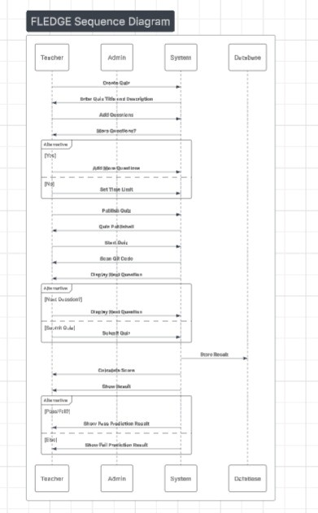

Figure 8 Sequence Diagram

Database Design

Database design is essential for any application, especially for data storage projects. Since the chatting method involves storing the message in the table and produced to the sender and receiver, proper handling of the table is a must. In the project, the user table is designed to be unique in accepting the username, and the username and password length should be greater than zero.

Entity relationship diagram ERD (database diagram)

An entity-relationship (ER) diagram is a specialized graphic illustrating the interrelationships between entities in a database.
Constitute a significant data modeling tool that will help organize your project's data into entities and define the relationships.
An ER diagram is a diagram that helps to design databases efficiently.

Building blocks of ERD

There are three essential elements in ERD:

- Entities: are the "things" about which we seek information.

- Attributes: are the data we collect about the entities.

- Relationships: provide the structure needed to draw information from multiple entities.

Types of Relationships

Many types of relationships can be classified into one-to-one, one-to-many, many-to many, and many-to-one.
One-to–many relationships: The relationship that associate one entity with more than one entity is called -to - a relationship: for example, a man can marry four wives, so one man may have more than one wife; hence this is an example of a one-to-many relationship.

One-to-one relationship: For each entity in one table, there is at most one associated entity in the other table.

Many-to-many relationship: a relationship between many entities; for example, the students are taking many courses in the University, so there are many-to-many relationships between students and classes.

Many–to–one relationship: The relationship between EMPLOYEE and Manager is an example of many to one relationship.
Entity

One-to-one One-to-many

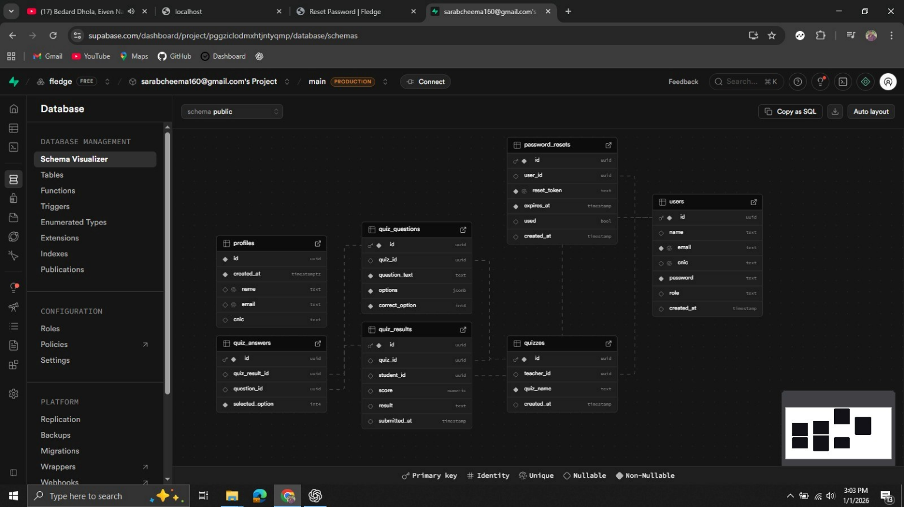

Figure 9 Entity relationship diagram ERD.

CHAPTER 5

IMPLEMENTATION

Introduction
When the system was tested, the implementation phase started. An essential stage in the system development life cycle is successfully implementing a new system design. Implementations mean converting new system design into operation. This is the moment of fact; the first question that strikes everyone's mind is whether the system will be able to give all the desired results as expected from the system. The implementation phase is concerned with user training and file conversion. The goal of the implementation phase is to implement a technique correctly, efficiently, and quickly on a particular set or range of computers, using specific tools and programming languages in Online Tailoring Website; no person can log in without any account.
After the analysis Phase, the Design process is performed. In Interface design, we will build the website from the activities we collected from the analysis. All this web application's pages are responsive, and each page's interface fits the device screen accordingly. We will show interfaces as per the standard laptop screen here.
So, for now, we have the following entities.

Front End User Panel:

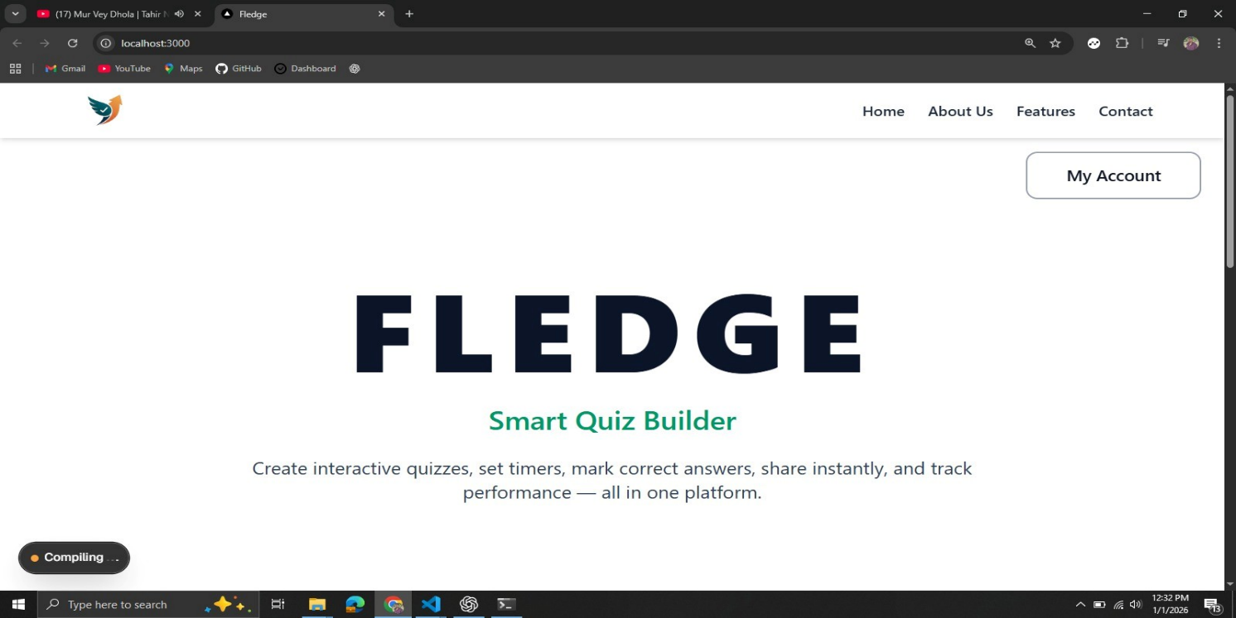
Figure 10 Landing page.
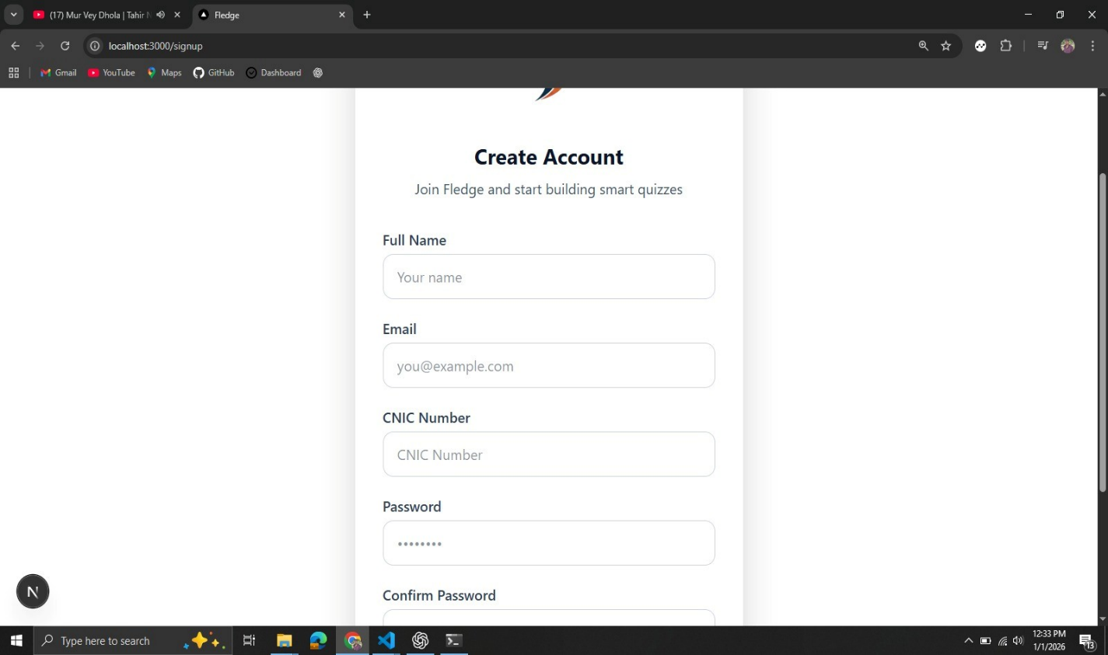

Figure 11 SignUp Page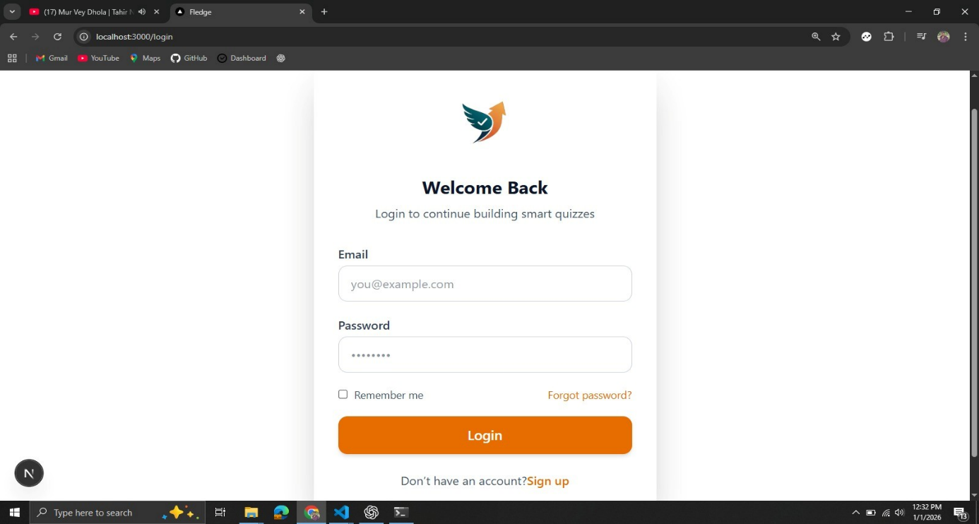
Figure 13 Login Page
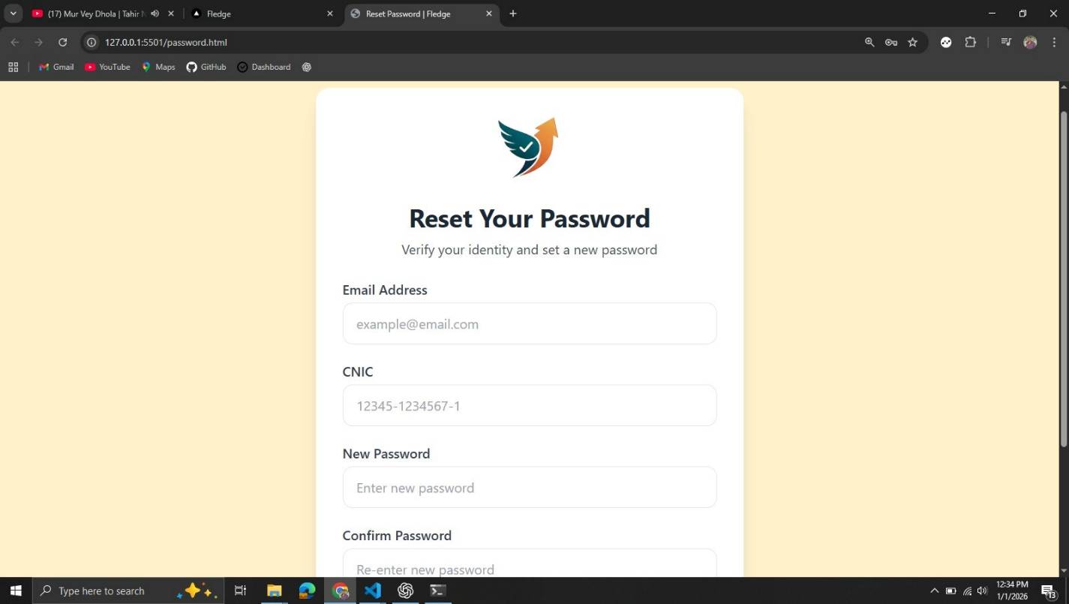
Figure 14 Forgot Password Page
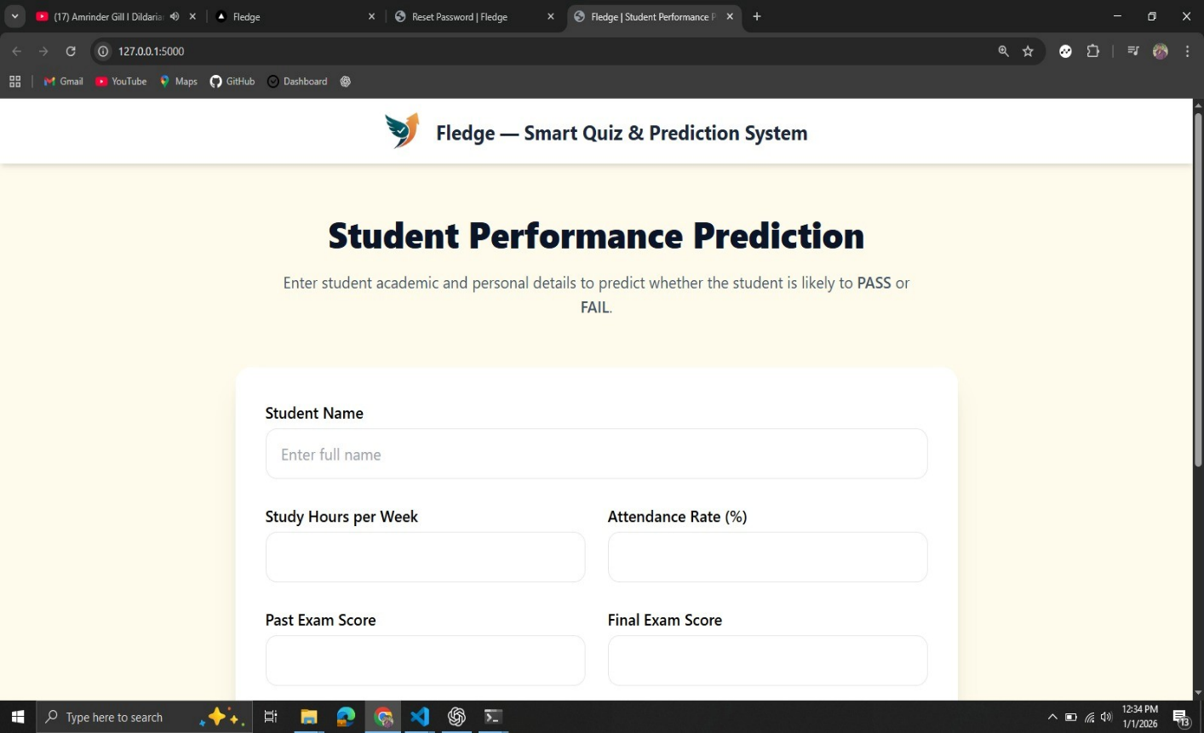
Figure 15 Performance Prediction Page

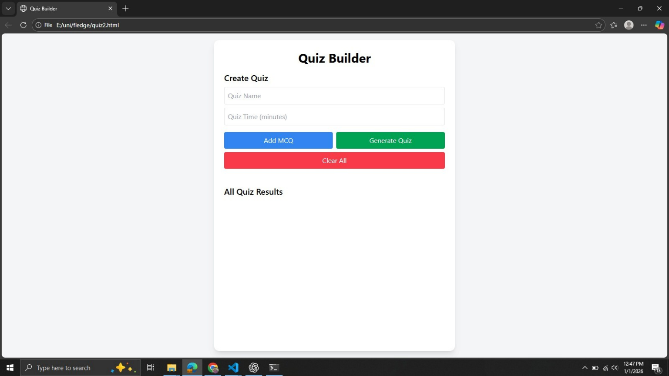
Figure 18 Quiz Building Page

5.3 Hardware and Software Requirements
To use the Task Flow Team Task Manager system efficiently, the following minimum hardware and software requirements are recommended.

5.3.1 Hardware Requirements
The system can run on standard computing devices with the following minimum specifications:
- Processor: Intel Core i3 or above
- RAM: 4 GB or above
- Storage: 256 GB HDD / SSD or above
- Monitor: 14-inch display or above
- Keyboard: Standard USB keyboard
- Mouse: Standard USB mouse
- Internet Connection: Required for accessing the web application.

5.3.2 Software System Requirements
Client-Side Requirements:
- Web Browsers: Google Chrome, Mozilla Firefox, Microsoft Edge
- Operating System: Windows 10 or above, macOS, Linux
Server-Side:
- Backend: Node.js
- Database: Supabase
- Frontend: React.js, Tailwind CSS, JavaScript.

CHAPTER 6

TESTING

Introduction
After the completion of the coding and implementation phase, the next critical step in the software development life cycle is testing and debugging. Testing is the process of executing a software system with the intent of identifying errors, defects, or missing requirements. It ensures that the system functions according to the specified requirements and meets user expectations.
In the Task Flow – Team Task Manager, testing was conducted to verify the correctness, reliability, security, and performance of the application. Each module of the system was tested individually and then as a complete system to ensure smooth interaction between frontend and backend components.
Once errors were detected during testing, the debugging phase was initiated. Debugging involves locating the root cause of the detected error and correcting it to ensure proper system behavior.
The debugging process involves the following possible outcomes:
- The error cause is identified and corrected.
- The error cause is difficult to locate.
- Fixing one error may expose another hidden error.
- Errors may be caused by incorrect logic or invalid user input.
- Timing issues or data inconsistency may produce unexpected results.
- Errors may occur intermittently.
- Issues may arise due to improper authorization or authentication handling.
- Distributed components (frontend, backend, database) may introduce integration-related issues.

Types of Testing
Testing is a continuous process carried out throughout the development of the system. The main objective of testing is to identify defects and ensure that the software behaves as expected under various conditions.
If testing is performed effectively, it helps uncover errors and ensures that:
- The system performs according to specifications.
- Functional and non-functional requirements are met.
- Security vulnerabilities are minimized.
It is important to note that testing cannot prove the complete absence of errors, but it can demonstrate that errors exist and must be resolved.

System testing
Performing various on to perform functionality or identify a system is usually done before and after a procedure is put in place. A series is referred to while testing is performed.
These procedures tell the tester how the system should perform and where it maybe found. Testers usually try to “break the system”, which may cause the system to malfunction. For example, a tester may put in a city designed only to see how the system will respond to the incorrect.

Unit testing
Unit testing is a development process in which the minor testable parts, called units, are individually and independently scrutinized for proper operation. Unit testing is often automated, but it can also be done manually. This testing mode is a component of a pragmatic method of software development that takes a meticulous approach to building a product utilizing continual testing and revision.
Unit testing involves only those characteristics that are vital to the performance of the unit under test. This encourages developers to modify without immediate concerns about how much changes might affect the functioning of the other departments or the program. Once all of the units in a program are working in the most efficient and error-free manner possible, more prominent components of the program can be evaluated: employing Uni testing can be time consuming and tedious. It demands patience and thoroughness on the part of the development team. Rigorous documentation must be maintained. Unit testing must be done with an awareness that it may not be possible to test a unit forever input scenario that will occur when the other program is run in a real-world environment.

Documentation
In the development of the computational software, product documentation is the information that describes the product to its users. It consists of the product technical information manual. (Including. The technical manuals that help facility descriptions)
Standard documentation responds to a specific set of instructions in defined manner: a database is phrase used to describe any software for creating and managing the information stored. The term is also sometimes used to mean the source information contained in design documents, detailed code comments, white papers, and blackboard session notes.
So that the central principle of documentation resources helps managers at all levels to improve their performance. To provide a substantial knowledge base for managing documents of all kinds. Weekly updates keep you in touch with the latest project document management. The purpose of documentation is to support a tool or a process. Classical documentation is a set of documents printed on paper. Documentation (to document) also refers to the process of providing evidence.

Test Case ID | Test Description | Expected Result | Actual Result
TC1 | Verify user can access Login page | Login page loads with required fields | Passed
TC2 | Verify user login with valid credentials | User authenticated and redirected to dashboard | Passed
TC3 | Verify quiz creation with default time | Quiz saved successfully in database | Passed
TC4 | Verify MCQ addition with correct option | MCQs stored correctly with correct answers | Passed
TC5 | Verify QR code generation for quiz | QR code generated and linked to quiz URL | Passed
TC6 | Verify student can access quiz via QR code | Quiz page opens successfully | Passed
TC7 | Verify quiz attempt and auto-submit on time expiry | Quiz auto-submitted when timer ends | Passed
TC8 | Verify result calculation after quiz submission | Score and percentage calculated correctly | Passed
TC9 | Verify teacher can view results by quiz name | All student results displayed correctly | Passed
TC10 | Verify ML pass/fail prediction | Prediction displayed based on trained model | Passed

Table 8 Traceability Matrix

CHAPTER 7

CONCLUSION AND RECOMMENDATION

Fledge is a smart, QR-based online quiz platform that effectively automates the process of digital assessments. It allows teachers to create timed MCQ quizzes, generate QR codes for student access, and view results by quiz name. Students can attempt quizzes on the same page, receive instant scores, and benefit from a machine learning model that predicts pass or fail outcomes. The system leverages a secure database for storing quizzes, responses, and results, ensuring reliable data management. Overall, Fledge provides a fast, efficient, and intelligent solution that enhances both teaching and learning experiences.
It is recommended that Fledge be further enhanced by adding advanced security features, improved machine learning models trained on larger datasets, and detailed performance analytics for deeper insights. The system can also be extended to support different question types, user authentication, and cloud deployment for scalability. With these improvements, fledge can be effectively adopted by educational institutions as a reliable and intelligent online assessment platform.

Strengths
Every software system has strengths and limitations that are as follow:
- Easy quiz access using QR code scanning.
- Automated quiz evaluation and instant result display.
- Machine learning–based pass/fail prediction.
- Secure database storage for quizzes and results.
- Time-saving for both teachers and students.
- Mobile-friendly and user-friendly interface.
- Built with modern technology (Next.js).

Weaknesses
Despite its strengths, the system has some limitations:
• Machine learning prediction accuracy depends on the quality of the dataset.
• Requires stable internet connectivity to function properly.
• Limited to MCQ-based quizzes only.
• Basic security and authentication features.
• Not suitable for large-scale deployment without further improvements.
These limitations do not affect the core functionality but highlight areas for future improvement.

Future Enhancement
• Offline + Local QR Sharing
- Teachers can share quizzes locally without internet.
- Useful for schools with weak internet — ideal for Pakistan and developing countries.
• Gamified Results
- Show badges, rankings, and leaderboards.
- Give instant feedback like “You beat 80% of your class.”
• Analytics Dashboard
- View average scores, top performers, and question difficulty.
- Visualize student performance using charts.
• AI Quiz Generator (Future Upgrade)
- Teachers can paste a paragraph, and AI generates MCQs with correct answers.
- Potential killer differentiator for the platform.
• Quiz Sharing via Link or Code
- Generate a code (like “join game 1234”) to share quizzes.
- Students can join easily without scanning a QR.
• Institution Mode
- Each teacher has their own account.
- Students join the class using a code.
- Teachers can view all quizzes and student results.

Scope of the project
The scope of this project includes the design and implementation of a comprehensive web-based task management system with the following core features:
- Quiz Creation: Teachers can create timed MCQs with correct answers.
- QR Code Access: Students can scan QR codes to access quizzes quickly.
- Quiz Attempt: Students enter their name and attempt the quiz on the same page.
- Instant Results: Automatic calculation and display of scores after quiz completion.
- Database Storage: Secure storage of quizzes, responses, and results for easy retrieval.
- Performance Prediction: Machine learning model predicts pass or fail outcomes.
- User-Friendly Interface: Designed to be responsive and easy to use on mobile and desktop.

Software performance
- Efficient Operations: Handles multiple quizzes and student attempts simultaneously.
- Fast Execution: Quiz creation, QR code generation, and result calculation are quick.
- Optimized Database: Stores and retrieves quizzes, responses, and results accurately and efficiently.
- Machine Learning Prediction: Predicts pass/fail outcomes quickly for instant feedback.
- Reliable and Stable: Ensures smooth performance and minimal errors during real-time usage.

Recommendation
To further improve Fledge, it is recommended to enhance the security features by adding stronger authentication and data encryption to protect quizzes and student information. Expanding support for different question types, such as short answers, true/false, and essay questions, would make the platform more versatile. The machine learning model can be improved by training it on larger and more diverse datasets for more accurate pass/fail predictions. Additionally, deploying Fledge on the cloud would allow scalability and global accessibility, while adding detailed performance analytics and reporting features could help teachers gain deeper insights into student performance. These enhancements would make Fledge a more robust, intelligent, and widely usable digital assessment platform.

REFERENCE

[1] I. Sommerville, Software Engineering, 10th ed., Pearson Education, 2016.
[2] R. S. Pressman and B. R. Maxim, Software Engineering: A Practitioner’s Approach, 8th ed., McGraw-Hill Education, 2015.
[3] Mozilla Developer Network (MDN), “JavaScript Documentation,”
Available: https://developer.mozilla.org/en-US/docs/Web/JavaScript
[4] React Documentation, “React – A JavaScript Library for Building User Interfaces,”
Available: https://react.dev/
[5] Tailwind CSS Documentation, “Utility-First CSS Framework,”
Available: https://tailwindcss.com/docs
[6] Node.js Foundation, “Node.js Official Documentation,”
Available: https://nodejs.org/en/docs/

